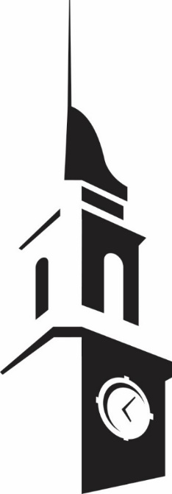
Presents

Musician Name
(Instrument) Recital

assisted by:
Accompanist Name, collaborative pianist

Month XX, 20XX
Room XXX, XXXXX Building
X:XX pm

The X presentation by the EKU School of Music
for the 20XX-20XX Season
Program
Title of Music Composer
(Year of birth-death)
I. Movement Title
II. Movement Title
III. Movement Title

Performing musician name, instrument

Title of Music Composer
(Year of birth-death)
II. Movement Title

Performing musician name, instrument
Accompanist Name, piano

Title of Music Composer
(Year of birth-death)
I. Movement Title
II. Movement Title
III. Movement Title

Performing musician name, instrument
Accompanist Name, piano

This recital is in partial fulfillment of the Bachelor of Music Education degree. Performing Musician name is a student of Dr. Xxxxxx Xxxxxxx. (Inside Cover)
Program Continued/Program Notes (page3)
Title of Music Composer
(Year of birth-death)
I. Movement Title
II. Movement Title
III. Movement Title

Performing musician name, instrument

Title of Music Composer
(Year of birth-death)
II. Movement Title

Performing musician name, instrument
Accompanist Name, piano

Title of Music Composer
(Year of birth-death)
I. Movement Title
II. Movement Title
III. Movement Title

Performing musician name, instrument
Accompanist Name, piano

Program Notes (page 4)
This is where you write the program notes.

Guest Performer/Soloist (page 5)
This is where you write guest performer info/ soloist info

Guest Performer/Soloist (page 6)

Ensemble Performers (page 7)

CHECK OUT OUR WEBSITE: WWW.MUSIC.EKU.EDU
Upcoming Events
All events are at 7:30pm unless otherwise noted,
please check the calendar online for updates
EKU GUEST ARTISTS:
Sean Hawthorne, Cellist __________________ Room 100, Foster, 4 Nov 2022
Antonella Franco & Joao Kienen, _____ Gifford Theatre, Campbell, 8 Nov 2022
Faculty Recitals:
Streetman & Strings ______________ Brock Auditorium, Coates, 26 Aug 2022
Dr. Nathan Jasinski, Cello __________ Gifford Theatre, Campbell, 14 Oct 2022
One Night Only, Voices with Jazz ____ Brock Auditorium, Coates, 27 Oct 2022
Large Ensemble Concerts:
EKU Concert Band Concert ________ Brock Auditorium, Coates, 21 Sept 2022
EKU Wind Ensemble Concert _______ Brock Auditorium, Coates, 22 Sept 2022
EKU Symphonic Orchestra Concert ____ EKU Center for the Arts, 26 Sept 2022
EKU Jazz Ensemble Concert _________ Gifford Theatre, Campbell, 4 Oct 2022
EKU Choral Concert _______________ Gifford Theatre, Campbell, 6 Oct 2022
EKU Wind Ensemble Concert ________ Brock Auditorium, Coates, 1 Nov 2022
EKU Concert Band Concert __________ Brock Auditorium, Coates, 2 Nov 2022
EKU Jazz Ensemble Concert ________ Gifford Theatre, Campbell, 15 Nov 2022
Deck the Halls, one night only _______ Ballroom, Keen Johnson, 18 Nov 2022
EKU Band Concert _________________ EKU Center for the Arts, 20 Nov 2022
EKU Symphonic Orchestra Concert ____ EKU Center for the Arts, 21 Nov 2022

