210 Survey Requirements

210.1 Surveys for Capital Construction Projects: On Capital Construction projects, the Architect-Engineer shall request surveying services as necessary for the Project. The request is made to the Project Manager.

All survey documents must be completed in ArcGIS format. (See 210.6)

The Project Manager will then initiate the Purchase Order process. (See Section 209) The information obtained from the survey shall be submitted to both the Project Manager and the Architect-Engineer for their use on the Project.

210.2 Boundary and Topographic Surveys: The Project Manager will coordinate with the Architect-Engineer on the requirements for a survey. The Architect-Engineer will provide recommendations as to the extent of topographic surveying that is required for the Project including boundaries, easements, contour intervals, site feature location, etc. AIA Document G601 may be used to assist the Architect in requesting a proposal for a Land Survey. The survey shall be made available to the Architect–Engineer for use in the design of the Project. This information shall be included in the contract documents.

210.3 General Requirements:
- Authorization shall be received from DFMS to provide a boundary survey and legal description and /or topographical survey. This authorization may be accompanied by an attorney’s title opinion.
- In the process of preparing a site survey, the surveyor is to determine and indicate on the site survey drawing whether any of the site surveyed is subject to flood hazards or not, using the National Flood Insurance Program criteria. The legal description of the property shall include a statement as to whether or not any portion of the property is in a flood prone area. In the event the property is determined to be flood prone the surveyor and/or the Architect-Engineer shall contact the Project Manager.

210.4 Site Survey Requirements: Site surveys shall include the following:

- Site boundaries shall show bearings and distances and indicate whether bearings are true or magnetic.
- Topographic surveys shall show one (1) or two (2) foot contour intervals as determined by the Architect - Engineer and the Project Manager.
- An established permanent benchmark with all elevations and topography related to it. The benchmark elevation is to be tied to the U.S.G.S. Elevations.
- All appropriate utilities include but are not limited to the following:
- Sanitary and storm sewers including all manholes, pipe diameter sizes and invert elevations.
- Steam and chilled water lines
- Gas lines
- Domestic and fire water lines
- Underground or overhead electric and communication lines and poles
- All off-site utilities which might reasonably be used to serve the project

- The topographic survey shall identify all existing streams, ponds and drainage ways located on the site to assist with determining permit requirements

- The scale for surveys that will be the basis for site design and will be a part of the contract documents shall be as jointly determined by the Architect – Engineer and the Project Manager. Scale shall not be less than 1” = 30’-0” unless approved by the Project Manager.

- Permanent coordinates from which subsurface investigations and construction locations can be determined shall be included. These permanent coordinates shall be coordinated with the Architect-Engineer for a location outside of the physical configuration of the structure.
- Typically, information required for a building project is a Quality Level C as determined by the American Society of Civil Engineers CI/ASCE 38-02 “Standard Guidelines for the Collection and Depiction of Existing Subsurface Utility Data”.

210.5 Sample Property Marker

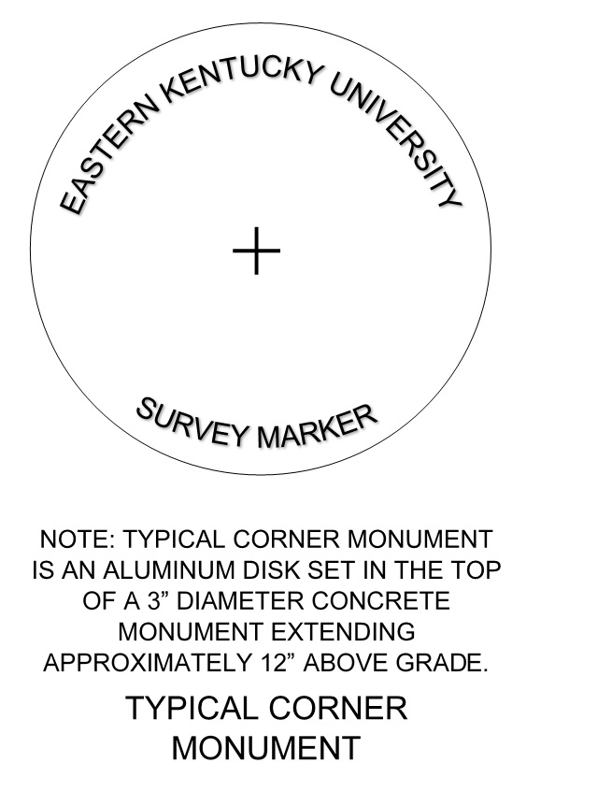
210.6 Distribution of the Completed Site Survey Work: The survey submittal shall be as follows:

- ArcGIS electronic copy and 2 prints shall be sent to the Project Manager. Refer to EKU ArcGIS standard https://facilities.eku.edu/eku-dfms-procedures-manual Chapter 2 - Pre Design 00 210.1 EKU GIS Guidelines

- If the survey is to be included in contract documents for a construction project, then the survey shall be submitted to the Architect-Engineer on mylar that utilizes an EKU title Block. The size of the drawings shall be coordinated with the Architect-Engineer.

