220 – SWPPP Storm Water Pollution Prevention Plan

General Information:

- Storm water management is currently regulated nationwide by the National Pollutants Discharge Elimination System (NPDES). Storm water management is regulated locally by the companion State program, KPDES.
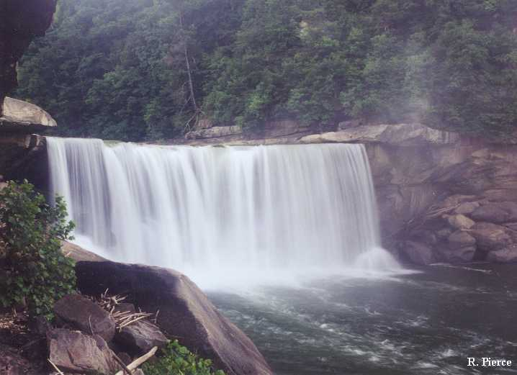
Problems encountered by the Kentucky
Division of Water regarding erosion control
violations, sediment loss, and pollutants from
construction activities, require a detailed
procedure for storm water management.
- The procedure detailed in this manual will apply to all Capital Construction Projects managed under the jurisdiction of the DFMS.
Key Points

- Soil sediment transported from construction sites is a visible and very real problem. It turns clear streams muddy, clogs downstream intakes for private and municipal water supplies, and alters the aquatic environment and natural stream habitat.

- Water pollution from construction debris, petroleum products, and chemical wastes at construction sites also has a measurable impact on surface waters, affecting their suitability for drinking, fishing, swimming, and other activities. Even when a construction site is not immediately adjacent to a visible stream, those pollutants eventually find their way, via tributary drainage or sub grade flow, to downstream surface waters.

- The EPA is pursuing vigorous enforcement of the regulations covered by Phase 2 of NDPES.

- Fines for violations can be significant and can be assessed against both the Contractor and the Owner.

Chronology

- 1972 – In response to serious and repeated environmental concerns, Congress enacted the Clean Water Act.
- 1983 – Kentucky received “primacy”, or authority to administer that federal program.
- 1987 – The Clean Water Act was amended to include “industrial storm water”, which by definition includes construction sites.
- 1992 – The EPA Storm Water program began with Phase 1, covering all sites of 5 acres or more.
- March, 2003 – Phase 2 kicked in, effectively reducing the site coverage to 1 acre or more.

Projects required to be covered under KPDES

- Construction sites of 1 acre or more
- Construction sites of less than one acre if they are part of a larger development plan, campus, master plan, or project
- Operators of Municipal Separate Storm Sewer Systems (MS4), or construction projects that exist in MS4 jurisdictions– EKU has been designated as MS4 and operates under KPDES permit KY G200000. Refer Section 220.1 EKU MS4 Storm Water Control Requirements for additional detail and implementation.

- Industrial facilities in any of 11 categories – (not included in this Manual)

This manual will primarily be concerned with Construction Sites in Items 1, 2, and 3.

The DFMS requires the following steps:

- Scope of Work: Erosion control will now follow predetermined design and detail criteria. This will take the form of a Storm Water Pollution Prevention Plan (SWPPP), as further detailed in this Manual and in other manuals available from the Division of Water.

- Preparation of the SWPPP: This SWPPP design will be prepared by the Architect-Engineer. This SWPPP will be included in the bid documents given to bidding contractors. The Architect-Engineer must complete the Storm Sewer Plan Review Checklist (see section 220.2 Storm Sewer Plan Review Checklist).

- Permitting: Following Contract Award, the Contractor shall acquire a storm water permit by submitting a Notice of Intent (NOI) to the Division of Water. Contractor must send approval of NOI from the Division of Water to DFMS.

- Construction Standards: The Contractor will be required to install all erosion control features according to the plan, details, and specs in the SWPPP as prepared by the Architect-Engineer.

- Maintenance: The Contractor is required to keep on site a maintenance log of all erosion control features and will be required to inspect, cleanout, replace, or modify all features during the course of the project as they respond to weather and storm water.

- Inspection: The Architect-Engineer is responsible for reviewing these features, periodically as appropriate, and enforcing maintenance.

- Awareness: All Architects and Engineers are responsible for Storm Water Pollution Prevention.

Explanation of the Storm Water permitting process required for Capital Construction projects managed by DFMS.

- There are two types of KPDES permit: Individual and General. Nearly every construction project generated by the DFMS will be covered under a General Permit. (Exceptions are noted in the General Permit itself.)

- In 2002 the Kentucky Division of Water (DOW) issued one General Permit to cover all applicants. New construction projects merely apply for coverage under this General Permit.

- The Architect-Engineer shall prepare a Storm Water Pollution Prevention Plan (SWPPP) for the project.

- The SWPPP must be designed and stamped by a Civil Engineer or Landscape Architect registered in the State of Kentucky.

- The SWPPP does not have to be submitted to the Division of Water for review and approval.

- The SWPPP is site-specific. It consists of carefully designed and constructed storm water management and erosion control features. These specific features are collectively referred to as Best Management Practices (BMP’s).

- Design calculations for storm water flow for the SWPPP are required for large sites or sites that receive substantial storm water from adjacent watersheds. These calculations shall be made available to the Division of Water, if requested, including flow volumes, velocities, storage capacities, ditch/pipe sizes, or other appropriate hydrologic or hydraulic considerations.

- The SWPPP shall include a recommended Maintenance Schedule for each BMP.

- For every Capital Construction project, application for General Permit coverage shall be made by the Contractor immediately after the Contract Award. This application is based on the SWPPP already prepared by the Architect-Engineer and included on the Contract Documents.

- Coverage under the General Permit is automatic and only requires the submittal of a Notice of Intent (NOI). The KPDES General Permit is available at: http://water.ky.gov/permitting/Pages/WastewaterDischarge.aspx

- If a Capital Construction Project for the DFMS is located in a municipality that is designated by the Division of Water as a Municipal Separate Storm Sewer System (MS4), then the Project is subject to review by that MS4 and must meet separate regulations of that MS4. Local MS4 regulations cannot lessen the regulations required by EPA, but they may be more stringent or require additional criteria.

The term MS4, however, does not solely refer to municipally-owned storm sewer systems. It can also include State Departments of Transportation, local sewer districts, universities, hospitals, prisons, and military bases. An MS4 is also not always just a system of underground pipes. It can include roads with drainage systems, gutters, and ditches.

A list of MS4 permittees currently recognized by the Division of Water is available from that agency (502-564-3410), along with contact persons. In Kentucky, MS4’s are categorized as small, medium and large, as follows:

- Large – Louisville metropolitan area
- Medium – Lexington metropolitan area
- Small – Smaller urban communities listed by the Division of Water

If a town, city or community is not on the list and the Division of Water does not designate that town as a MS4 at the time of the NOI, no additional MS4 requirements will apply.

- The Architect-Engineer shall include the SWPPP as part of the Construction Documents.

- The Contractor shall provide all construction and maintenance shown on the SWPPP as part of the contract scope of work.

- Following bid and contract award, the Contractor shall submit a site phasing plan or other related documents that may influence or affect the performance of the SWPPP.

- During the Construction period, the Contractor shall keep on site the following:
- Copy of the NOI
- Copy of the SWPPP along with all related written documents
- A Maintenance Log Book (see sample Log Book sheet in this Manual)

- The Maintenance Log Book shall identify the following:

- A list of every BMP on the project.
- The Contractor’s plan for how often each BMP should be reviewed.
- Condition of each BMP following any scheduled inspection or significant storm event.
- The Contractor’s action for repairs, replacement, etc. for each BMP following any scheduled inspection or significant storm event.
- Any comments pertinent to the performance of the entire SWPPP in general and any BMP’s in particular.
- The Contractor shall submit the Maintenance Log schedule to the Architect-Engineer for review and approval prior to beginning construction.

- During the entire construction period, the Contractor’s superintendent or other duly authorized field representative shall:
- inspect all BMP’s as listed in the Log Book,
- note the condition and performance of each BMP,
- take corrective action for each BMP, as required.

- The Architect-Engineer shall also inspect the BMP’s at regular progress meetings or other normal intervals, just as they would inspect the basic construction work. They shall enforce construction standards for these BMP’s.

- During the construction period the Contractor will promptly repair, rebuild, replace, clean out, or otherwise modify any BMPs that require attention or that do not perform as required. The Contractor will note in the Maintenance Log what maintenance or reconstruction was required and any action taken.

- For any BMPs that do not appear to perform as designed, the Contractor shall notify the Architect-Engineer for review. If the Architect-Engineer and/or DFMS determine that a BMP needs to be redesigned or replaced with another more appropriate BMP because the design is not adequate, then the Contractor may request a change order to perform this work. If the BMP has not been installed correctly or not maintained appropriately per the contract documents, then the Contractor shall correct the installation at his expense.

- Upon completion of the project and once final vegetative cover has been established to the satisfaction of the Architect-Engineer, the Contractor will remove all non-structural BMP’s and submit a Notice of Termination (NOT) to the Division of Water. The Contractor must send a copy of the NOT to DFMS.
