106.6A. EKU Sustainable Building Guidelines
Eastern Kentucky University is committed to becoming a vibrant, productive living and learning community that exemplifies best practices in environmental stewardship through holistic application of sustainability principles across its functions as an academic institution. EKU aspires to become a leader in sustainability in higher education. Furthermore, EKU is committed to not only minimizing the environmental impacts associated with the construction, renovation, and operation of its built environment, but also to proactively designing high performance, sustainable buildings. To learn more about EKU’s sustainability goals, visit http://sustainability.eku.edu/ .
*Refer to Section 106.6 Projects Seeking LEED Certification for KAR statutory requirements

In addition to the statutory requirements outlined in 200 KAR 6:070, EKU requires the following process to be completed for new construction and building renovation projects:

- All new construction and major renovation building projects for the amount of $5 million or more in budget shall be designed, built, and submitted for certification to achieve a rating of Silver or higher using the LEED V4 - New Construction Project Scorecard.
- All new construction or major renovation projects for the amount of $600,000 - $5 million shall be designed, built, and submitted for review by a member of EKU’s Division Facilities Management and Safety’s (DFMS) team involved with the project to achieve the rating of Certified or higher using the LEED V4 - New Construction Project Scorecard.
- Projects should follow the same procedure outlined in Section 106.6, as if they were to be submitted to the U.S. Green Building Council (USGBC), but instead be submitted, reviewed and approved by the EKU LEED AP or LEED GA involved with the project.
- It is expected that the Architect/Engineer will prepare an appropriate LEED checklist and review with the EKU LEED AP or LEED GA involved with the project.

Technical Guidelines & Specifications
Submeter Technologies – In all new construction and major renovation involving mechanical, electrical or plumbing (MEP) systems, utility submeters should be installed, at minimum, at the building level for electricity, water, steam, and natural gas as applicable to the building. All installed submeters should be compatible with University building management software and be calibrated upon installation for accuracy. EKU uses the following submeter devices as its standard products:
- Electricity Submeters – Veris Industries, ENERCEPT H8025/8026 Networked (N2 BUS) Power Meters
- Natural Gas Submeters – Actaris, Dattus Basic fM2 & fM3, Commercial & Industrial Gas Meters
- Water Submeters – EKU uses the following water submeter products:
  - Onicon, D-100 Flow Display With Network Interface
  - Badger Meter, High Resolution LCD Encoders, HR-E® LCD 4-20, HR-LCD 4-20 scaled/unscaled
  - Badger Meter, Recordall Combo Meter
- Steam Submeters – No standard product or model been selected. Where applicable, please consult with EKU’s CCPA team before purchasing and installing steam submeter systems.

Hydration Stations - In all new construction and renovation projects involving the installation of drinking fountains, at minimum one Elkay EZH2O Bottle Filling Station & Single ADA Cooler, High Efficiency Filtered 8 GPH Stainless (LZSG8WSSK) water bottle refilling station should be installed and made accessible to all building occupants per building floor.

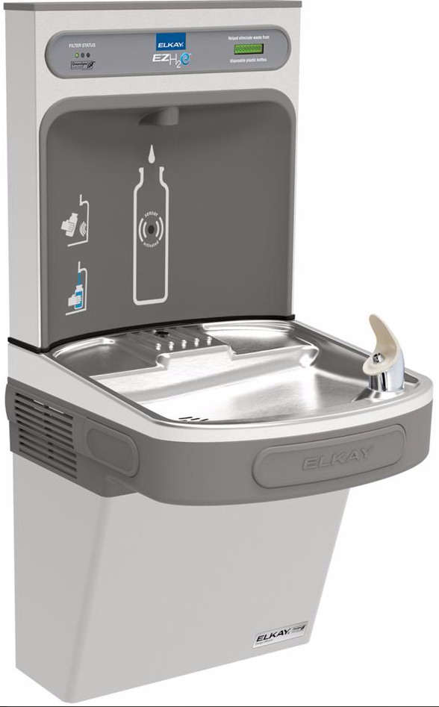

Bicycle Racks - In all new construction and major renovation projects requiring the installation of bike racks, at minimum one bike rack equipped to store at minimum 4 bicycles or 2.5% of peak visitors. Bike racks should be placed no more than 100 ft. away from any primary building egress and be accessible to all building users. Bike racks must not be placed in locations which violate local fire code.

Indoor Waste Bins – For projects that include interior waste bins within their scope of work, the following guideline should be followed. “Three-bin” waste stations (includes the following three waste streams: landfill waste, plastic & aluminum, and paper) should be installed and made accessible to all building occupants per floor of occupied space. EKU uses 16 gallon, gray Rubbermaid Slim Jim containers as its indoor standard.
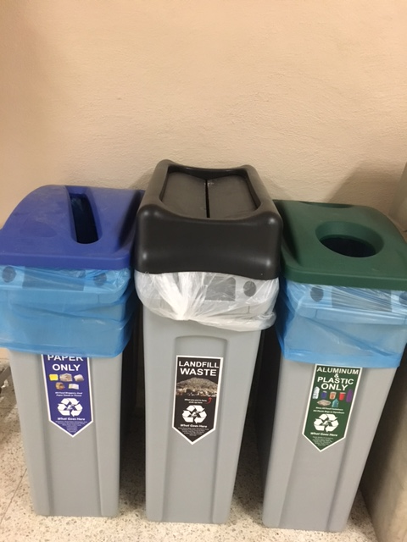
All waste stations should include: one bin with a blue paper recycling lid and a slotted rectangular opening, one bin with a black swing-top lid for trash, and one bin with a green bottle & can lid with two circular openings. EKU’s Office of Sustainability will provide appropriate labeling for each bin and informative “What Goes Where?” Signage for the location.
Indoor waste stations should be placed in high-traffic areas and building junctions, especially in locations where individuals are likely to search for waste containers. These areas might include, near building egresses, food and dining areas, elevators, vending machines, and major hallways. Ideally, placement should be consistent between building floors. Please contact EKU’s Office of Sustainability for guidance on placement of bins and to obtain labeling.

Outdoor Waste Bins – In all new construction and renovation projects requiring outdoor waste containers within the project scope, outdoor multi-stream waste station(s) should be installed within 100 feet of building egresses and be made accessible to all building occupants. In addition to bins located near building egresses, additional waste stations should be placed in areas of high foot-traffic within the scope of the project. These areas may include: main entrances, high traffic sidewalks, porch and outdoor seating areas, and busy sidewalk junctions. EKU uses Clean River Excel Front Access 35 Gal. Series, traditional style, brown, slant top bins (Reference Sales order # S17060013 for exact model). Reference Eastern Kentucky University and contact the EKU Office of Sustainability with any questions or concerns related to procuring the appropriate bin.
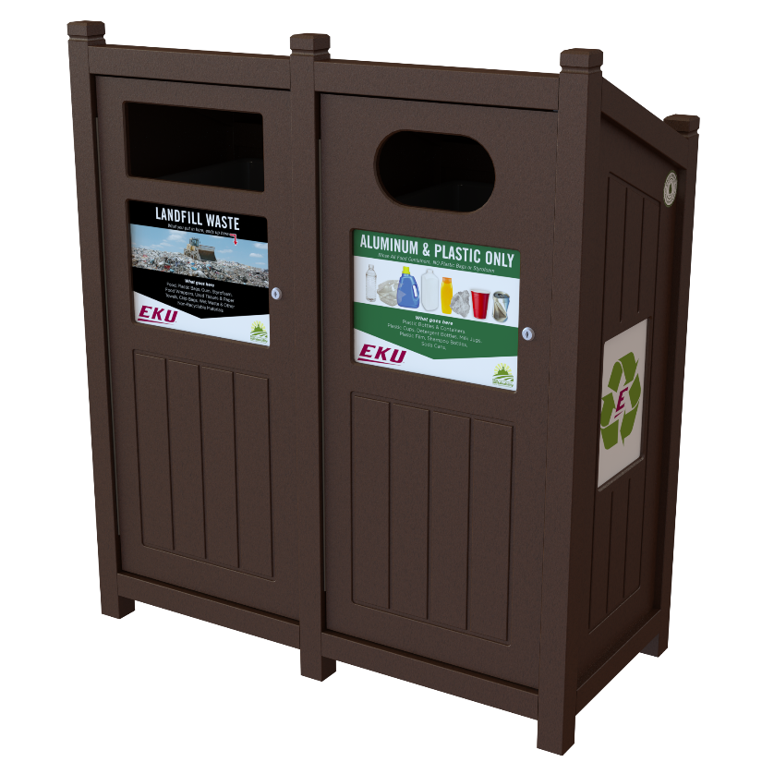

Hand Dryers - In all new construction and major renovations that include bathrooms, energy efficient hand-dryers should be installed in equal quantity as sinks per bathroom. Paper towel dispensers should not be installed unless recommended by the EKU DFMS team.

